Code: EXM-FR 01/1  ED:2.1 | FACULTY OF SCIENCES/Computer Science Dept.  Midterm Exam (Fall 2022-2023)  CSCI316-Introduction to Data Structure and Algorithms | 

Booklet Needed: No  Exam Date:15-Nov-22 | Ins. Name: Houssein Dhayne  Section: A |  | St. Name:  ID Number:
Grade: ……..…../100 |  | Exam Time: 16:30 – 18:00

Question 1 (30 points):
Create a generic class MyList which has an array of generic type (items) and an integer that indicates the number of items currently in the array.
- Add the following:
- Non-parameter constructor that creates the array with default size 10 items.
- Parameter constructor that creates the array with the size that input as a parameter.
- Method size() that returns how many elements currently in the array.
- Method add(T e), void method that adds item e to the end of the array if it is not full, otherwise it throws an exception.
- Method add(int i, T e}, void method that shifts the items and inserts item e at the position if the array is not full, otherwise it throws an exception.
- Method clear(), which is void method that removes all items from the array.
- Method get(int i) which returns the item at position i, if there is no item at that position it throws an exception.
- Method remove(int i), it removes the item at position i and return that item. It shifts the other items.

- Create a class Student that has: id (int), name (String), GPA (double).
- Add a parameter constructor that initialize the three properties.
- Add setter/getter methods.

- Create a main method that creates a MyList object and Student objects to test the methods of the MyList class.

public class MyList<T> {
private T[] items;
…
…
}

public class Student {
private int id;
…
…
public static void main(String[] args) {…}

}

Question 2 (20 points):
Suppose you have a class LinkedList which manages a singly linked list. Each item in the list is an object of class Node. The LinkedList class has a head reference that points to the first item and a tail that points to the last item in the list. An attached file contains the main methods implemented in the SinglyLinkedList.
Implement the following function as a new function for the linked list:
- getNth() function that takes an integer index and returns the data value stored in the node at that index position
- insertNth() which can insert a new element at any index within a list
- isCircular() function which check if the linked list is a circular linked list

public class SinglyLinkedList<E> {

private static class Node<E> {
private E element;
private Node<E> next;
public Node(E e, Node<E> n) { element = e; next = n; }
public E getElement() { return element; }
public Node<E> getNext() { return next; }
public void setNext(Node<E> n) { next = n; }

private Node<E> head = null;
private Node<E> tail = null;
private int size = 0;
public SinglyLinkedList() { }

.....
.....

Public ……… getNth(……… ){}
Public ……… insertNth(……… ){}
Public ……… isCircular(){}

}

Question 3(25 points):
- Give a big-Oh notation of the running time of the following codes.
1 | 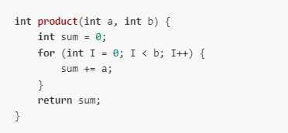
2 | 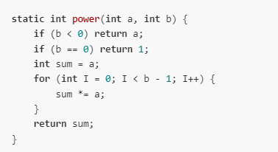
3 | 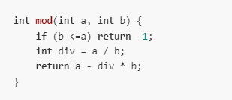
4 | 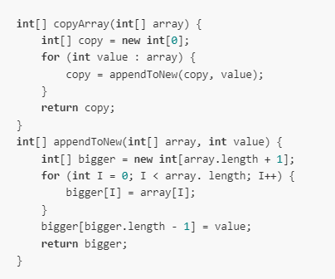

- Compare the worst-case big-O time analysis for these two functions: The remove First function for the sequence that is implemented using a fixed-sized array, and the remove First function for the sequence that is implemented using a linked list.

Question 4 (25 points):
Sometimes it is useful to have a linked list with pointers to both the next and previous nodes. This is called a doubly linked list and may be declared as shown.
public class DoublyLinkedList {

private static class Node {
private int element;
private Node prev;
private Node next;
public Node(int e, Node p, Node n) {element = e; prev = p; next = n; }

public int getElement() { return element; }

}

private Node head;
private Node last;
private int size = 0;// number of elements in the list

}
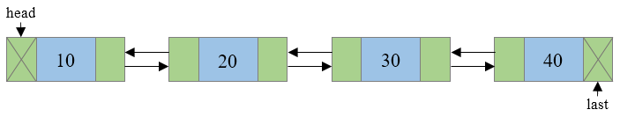
- Compare doubly linked lists with singly linked lists. When would you choose to use one over the other?
- Write a count() function that counts the number of times a given int occurs in the list.
- Write a reverse() function that reverses a list by rearranging all the next, previous pointers as well as the head and the last pointer.

